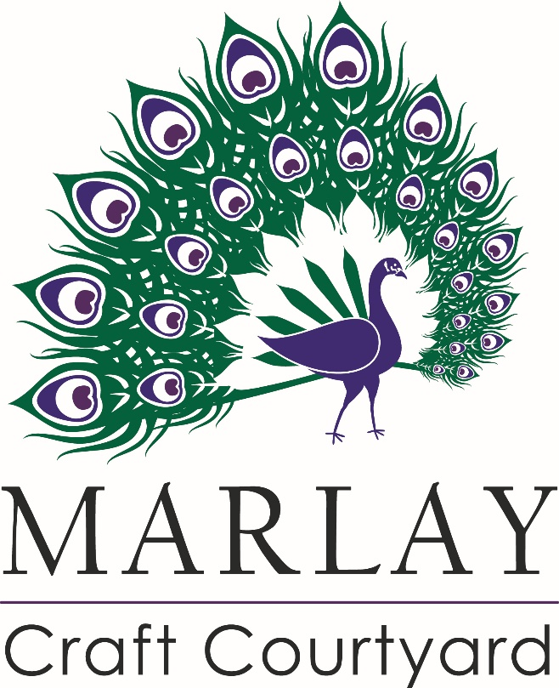
An Cúirt Ceardaíochta

Call for Expressions of Interest in the Marlay Craft Courtyard Project 2017

Dún Laoghaire-Rathdown County Council (dlr) is delighted to invite expressions of interest from Crafts people wishing to produce and retail their craft/crafts onsite in the newly refurbished Marlay Craft Courtyard facility in Marlay Park, Grange Road, Rathfarnham Dublin 16.

Marlay House and Craft Courtyard

Marlay House and Courtyard is located in Dún Laoghaire-Rathdown County Council’s jurisdiction and is the largest park in the Council’s ownership. The House and Courtyard are protected structures and are significant in the context of the Park which is a major local amenity used by the general public on a daily basis.
The restoration of the Marlay Craft Courtyard presents a significant opportunity to encourage new craft talent to set up business in this classic courtyard setting.
There are approximately 16 units in the current phase over two floors within the courtyard which have been restored to the highest standards with high public access and visibility. They will offer the finest craftspeople a special place to work and sell their products.

Eligibility
The Local Authority is particularly interested in receiving submissions from registered crafts people who offer a high quality, handcrafted product/products, produced and retailed onsite which will fit with the overall Marlay Ethos in terms of the use of this Heritage Building. The Council will also consider expressions of interest from a hand crafted Irish food supplier for occupancy of a ground floor unit. Again this producer/retailer will need to fit with the ethos of the project in terms of its sustainability within the Marlay Demense.
Terms of Engagement

Successful applicants will enter into a tenancy agreement with the Council with a lease term of 3 years. The leasee shall agree to all terms contained in the lease issued by the council.

Facilitated Visit to the Courtyard for interested Applicants

The Parks Dept will host a site visit to the Courtyard on 27th October from 10.a.m. to introduce the spaces and answer any specific questions. To book a place for this, please email Joe Burns at jburns@dlrcoco.ie. Facilitated Courtyard visits cannot be accommodated outside of this time.

Selection criteria

Applications will be evaluated using the following criteria;
Product Quality: (30/100)
Standard of Manufacture and finish
Commercial Suitability: (30/100)
Pricing, including export potential
Design and Innovation: (25/100)
Market-focused design, displaying
Innovation and quality
Quality of Marketing, point of sale and merchandising: (15/100)
Evidence of high quality marketing and promotional
Activity, strong POS, packaging or merchandising

Application

To apply, please deliver hard copies of the following to : The Senior Executive Officer, Facilities Management, Corporate Communications and Governance Dept. Dún Laoghaire-Rathdown County Council, Level 3, County Hall, Marine Road, Dún Laoghaire, Co. Dublin:
- 4 copies of a concise outline of the proposed craft business (200 words maximum)
- 4 copies of Craftworkers CV
- 1 Copy of example of work ( no more that 20 images in total) This should be submitted either as print-outs, such as photographs, or digital files in J-peg format on CD Rom. Videos must be submitted on CD Rom. Youtube, Vimeo links etc. may also be included with C.V. (please include any necessary passwords to access. ) All submissions should be PC/Microsoft Office compatible.
- A list of stockists of your product/products
The Parks Department will accept hard copy applications only. Email applications will not be accepted. Please note that applications will not be returned; valuable or irreplaceable materials should not be included with submissions. Adjudication will be conducted by the Parks Department and independent practitioners with crafts expertise. Candidates may be shortlisted based on their submission. The decision of the selection panel will be final. Please contact Dún Laoghaire-Rathdown County Council if you require this document in Irish.
All applicants will be notified regarding decision by email.

Closing date for applications: Friday 17th November 2017 @ 12 noon

Freedom of Information

The provisions of the Freedom of Information Act 1997-2003 apply to Dún Laoghaire-Rathdown County Council. Applicants should state if any of the information supplied by them is confidential or sensitive and should not be disclosed to a request for information under the aforementioned Act. Applicants should state why they consider the information to be confidential or commercially sensitive.

Retention of Data

Applicants should note that submissions will not be returned and should therefore ensure that no valuable or irreplaceable material is included in the application.
Please note that Dún Laoghaire-Rathdown County Council Parks Dept will retain submissions for one year from the closing date. All applications will be disposed of confidentially after this period.

Summary Timeline

Facilitated Courtyard Visit: Friday 27th October 2017 from 10.a.m.
Deadline for receipt of applications: Friday 17th November @ 12 noon
Successful applicants informed: December 2017
Occupation of units: Early 2018 ( dates to be confirmed)

For Further information

Please contact Joe Burns, e-mail: jburns@dlrcoco.ie or phone (01) 2047931

http://www.dlrcoco.ie/en/parks-outdoors

